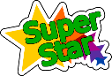

Super Me
EYFS Main Overview (Summary of Topic/Key Information)
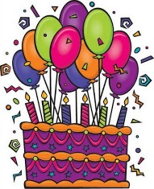
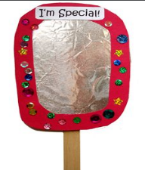
Elm class will be learning all about transition and starting school. They will be learning about their indoor and outdoor classroom settings, school areas, rules, expectations, routines, rocket groups, superstar colour groups, birthdays, feelings, emotions and friendships. The children will be learning all about their feeling/emotions, families, surrounding environments, bodies and what they can do and what makes them a superstar!
Key Facts | 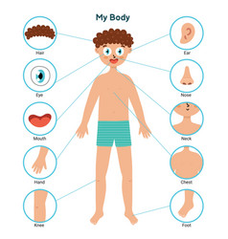  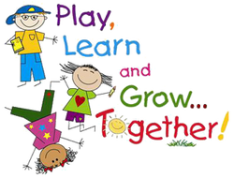  School is an exciting place to be to learn.  I will be safe and happy at school.  My body is special in many ways.  Sharing is caring.  My friends and teachers will help me at school.  My different feelings and emotions are all ok.  I can be independent but still ask for help if I think I might need it.
Key Questions | What will school be like? What will I be learning about at school? Who will help me? How can I make friends? How does my body work? What is inside my body? How can I look after my body? What does my body need? What makes me special? When is my birthday? What are my feelings and emotions? Why do I need to learn? Am I a superstar? Who can be my friend?
Subject | Key Skills Covered |  | Key Vocabulary
Personal, Social and Emotional  Development | Self-Regulation | 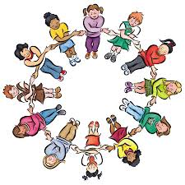  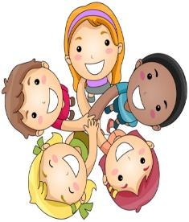  We will be learning about making different friendships at school. We will learn about new rules and what is expected. We will learn how to be independent and how to explore the indoor and outdoor areas with different teachers and friends. We will learn all about sharing, taking turns and how to keep safe. We will learn about the zones of regulation which will help us understand our feelings and emotions. We will be learning about what makes us a SUPERSTAR! | myself super friend friendship rules kind independence feelings emotions share teamwork listening expectation
 | Managing Self
 | Building Relationships
Physical Development | Gross Motor Skills | 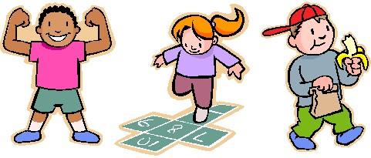  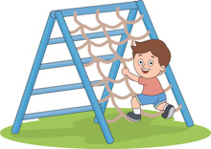  We will be exploring lots of physical sessions and activities in the hall and in our indoor and outdoor classroom areas. We will be learning how to get dressed and undressed independently. We will be learning about what our bodies can do and how to keep safe. We will be thinking about how we can be happy and healthy and how to follow many instructions. We will be focusing on multi skills and the parachute this term. | throw catch pass PE instructions safety healthy dress/undress finger gym  multi skills parachute
 | Fine Motor Skills
Communication and Language | Listening, Attention and Understanding | 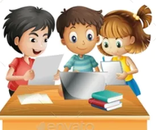  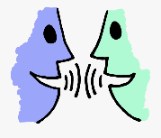  We will be learning about how we can listen, respond and talk about what we have heard. We will be exploring our thoughts and opinions. We will be designing and making our own book corner and role play area. We will be speaking in small groups and developing in confidence when talking in larger groups. We will be discussing hobbies, what we like, our families, our friends, what we dislike and where we live. | listen talk partner steps instructions role play story books sentence speaking confidence family friends look eyes ears speaking
 | Speaking
Literacy | Comprehension | 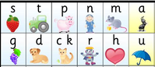  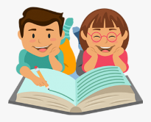  We will be learning how to read and write through a variety of sessions and activities. We will be writing our names and taking part in daily phonic whole class sessions. We will be reading our own books and learning many phonic sounds and sight words. We will be developing a true love of books and reading just like Miss Cox! | read write control grip story title setting character phonics sounds letters words formation patterns
 | Word Reading
 | Writing
Mathematics | Number | 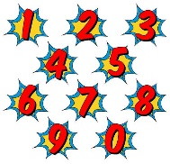  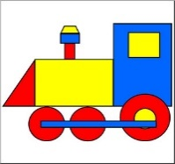  We will be learning about counting, recognising, matching, sorting and ordering numbers. We will be counting in 1s, 2s, 5s and 10s. We will be learning all about natural objects, grouping, patterns, 2D shapes, more, less and simple problem solving. | numbers 2D shapes square triangle rectangle circle star semi-circle hexagon pattern count order match sort repeat more less add subtract problem solving
 | Numerical Patterns
Understanding the World | Past and Present | 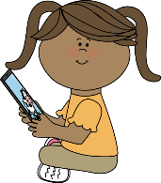    We will be learning about our new friends, family traditions and how to treat others around us. We will be learning about our world and all the different people who help us. We will be learning about growing in our outdoor area. We will be learning about technology and how to use different programmes and apps on the clever touch screen and ipads. | world care respect guinea pigs gentle help look after app programme safe  growing plants bulbs soil light water
 | People, Culture and communities
 | The Natural World
Expressive Arts and Design | Creating with Materials | 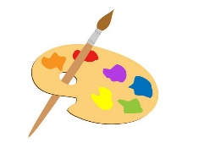  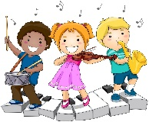  We will be learning about being creative in different ways. We will be learning about imaginative play, music, dance, movement and art and craft. We will be learning about our creative workshop area in the classroom and how to be safe when using tools (like scissors) and adapting our independent work. We will be exploring different materials and the developing our colour mixing skills. | colour design draw paint model imagination role play music beat rhythm song sing  move movement respond mixing colour names
 | Being imaginative and Expressive

