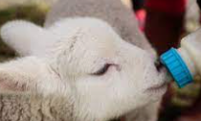

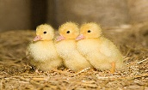
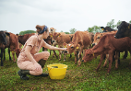
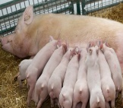
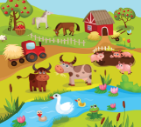
Fun On The Farm

EYFS Main Overview (Summary of Topic/Key Information)
Beech class will be learning all about an exciting new topic called Fun on the Farm. They will be learning about different animals, where they live and how to observe and care for them. We will be learning about different farm animals and what they need to be safe and happy. We will be learning about different life cycles and how baby animals are different from the adult animals. We will be learning about different animal charities and how they can make a difference to the welfare of different animals. We will be learning about farms around the world. We will also be going on a class trip to handle and feed different farm animals.
Key Facts | 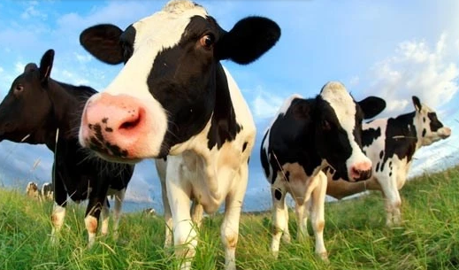  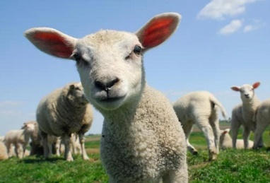  A farm is a piece of land used to grow crops and/or raise animals for produce. People who grow this produce are called “farmers”, and their work is called “farming”. Farms come in all shapes and sizes, with some being very large and others very small. There are many types of farming, which we’ll look at more closely. Some farms are run by people who eat the food they farm, whilst other farms, usually large ones, sell their products to many people far away in urban areas. A farm that raises dairy cows to produce milk and dairy products is called a dairy farm. Some breeds of chickens can lay colourful eggs. We get wool from sheep that can be used to make blankets, jumpers and hats. Horses can sleep standing up. Goats are great companions for other farm animals, including horses, cows, and chickens.
Key Questions | What is a farm? What are the names of different animals? How do animals move? What do they eat? Where do they live? What animals live on farms? Can farm animals be a pet? What do different animals feel like? What is a charity? What is a crop? Was does a crop need to grow? Where does milk come from? What is a baby pig called? What is a farmer? What jobs do farmers do?
Subject | Key Skills Covered |  | Key Vocabulary
Personal, Social and Emotional  Development | Self-Regulation | 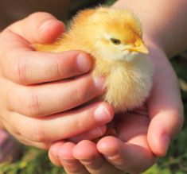  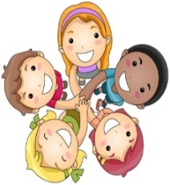  We will be learning about teambuilding and how we have formed different friendships at school. We will learn about how to look after animals and what makes different animals happy and feel safe. We will learn how to be independent and how to explore the indoor and outdoor areas with different teachers and friends. We will learn all about sharing, taking turns and how to keep safe. We will learn about the zones of regulation which will help us understand our feelings and emotions. | myself super friend friendship rules kind independence feelings emotions share teamwork listening expectation
 | Managing Self
 | Building Relationships
Physical Development | Gross Motor Skills | 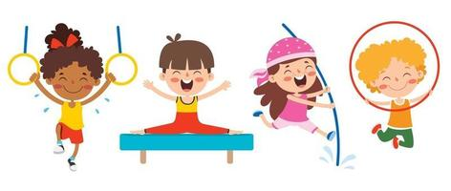  We will be exploring lots of physical sessions and activities in the hall and in our indoor and outdoor classroom areas. We will be learning about what our bodies can do and how to keep safe. We will be thinking about how we can be happy and healthy and how to follow many 2/3 step instructions. We will be focusing on gymnastics and dance in PE. | PE instructions safety healthy dress/undress  gymnastics, jump high low travel balance fast slow  Star jump pike jump straight jump pencil roll teddy roll
 | Fine Motor Skills
Communication and Language | Listening, Attention and Understanding | 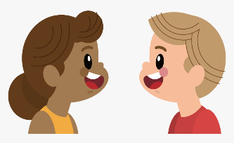  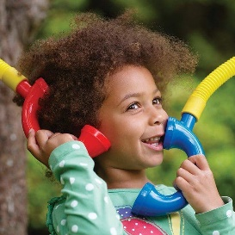  We will be learning about how we can listen, respond and talk about what we have heard. We will be exploring our thoughts and opinions. We will be talking about farms and how they are developed. We will be designing and making our own role play area that is linked to our new topic. We will be speaking in small groups and developing in confidence when talking in larger groups. | listen talk partner steps instructions role play story books sentence speaking confidence family friends look eyes ears speaking
 | Speaking
Literacy | Comprehension | 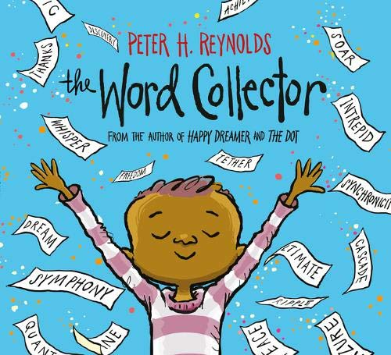  We will be learning how to read and write words, captions and simple sentences this term. We will be learning more sounds in our daily phonics sessions. We will be reading lots of animal books and learning many phonic sounds, sight words and new topic vocabulary. We will start to build our word collector wall so watch this space. | read write control grip story title setting character phonics sounds letters words formation patterns  letter word caption sentence
 | Word Reading
 | Writing
Mathematics | Number | 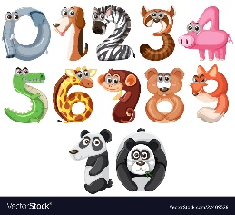  We will be learning about different numbers and how to develop a deeper understanding of number. We will also be learning about counting, recognising, matching, sorting and ordering numbers. We will be counting in 1s, 2s, 5s and 10s. We will be learning all about natural objects, grouping, patterns, 2D and 3D shapes, more, less height, length and simple problem solving. | numbers 2D/3D shapes square triangle rectangle circle star semi-circle hexagon pattern count order match sort repeat more less add subtract problem solving
 | Numerical Patterns
Understanding the World | Past and Present |   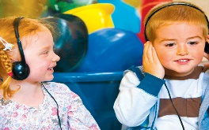  We will be learning about different animals that live in hot and cold environments. We will be learning how to look after different animals. We will be learning about technology and how to use different programmes and apps on the clever touch screen and ipads. We will be learning how to keep safe when exploring the internet. | world care respect guinea pigs gentle help look after app programme safe  growing plants bulbs soil light water
 | People, Culture and communities
 | The Natural World
Expressive Arts and Design | Creating with Materials |   We will be learning about being creative in different ways. We will be learning about imaginative play like how to move like different animals. We will be exploring two new musical topics called ‘everyone’ and ‘our world’. We will be exploring our creative workshop area, adapting our independent work and following visual instructions to make different crafts. | colour design draw paint model imagination role play music beat rhythm song sing  move movement respond mixing colour names
 | Being imaginative and Expressive

